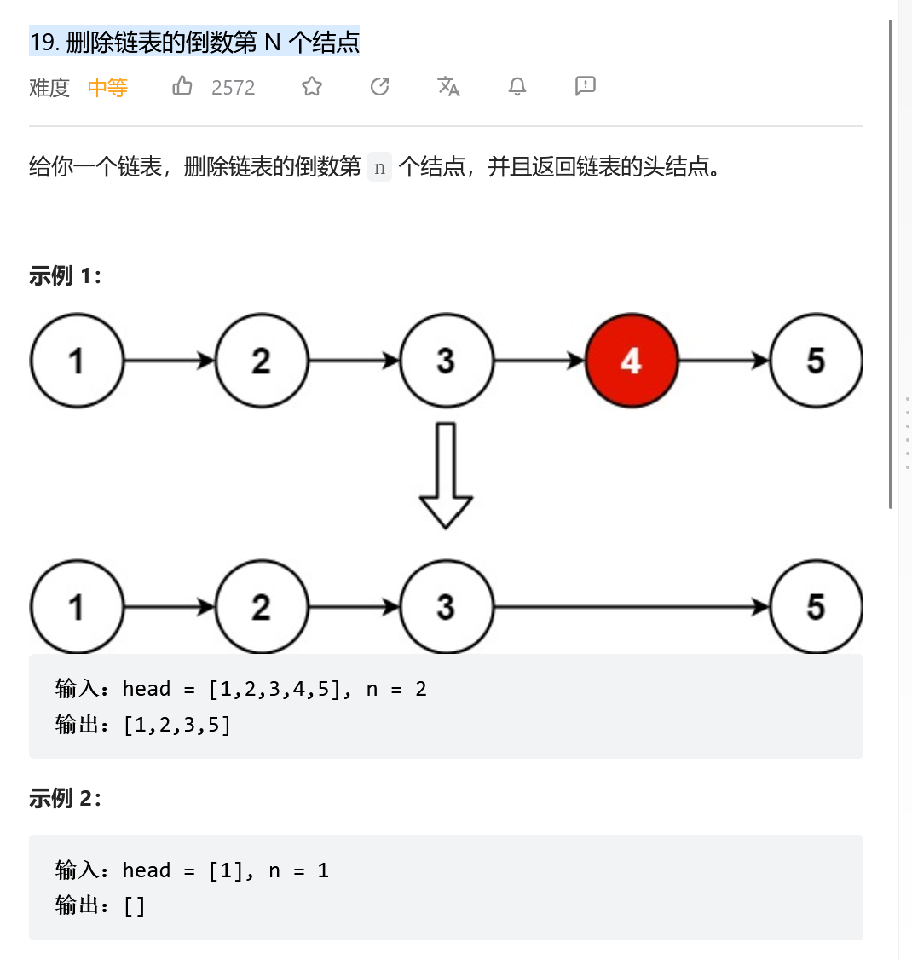
方法一：循环迭代 -- 找到 length -n 个节点

class Solution:
def removeNthFromEnd(self, head: ListNode, n: int) -> ListNode:
dummy = ListNode(0)
dummy.next = head

#step1: 获取链表长度
cur, length = head, 0
while cur:
length += 1
cur = cur.next

#step2: 找到倒数第N个节点的前面一个节点
cur = dummy
for _ in range(length - n):
cur = cur.next

#step3: 删除节点，并重新连接
cur.next = cur.next.next
return dummy.next
方法二：快慢指针 -- 找倒数第N个节点的前一个节点

class Solution:
def removeNthFromEnd(self, head: ListNode, n: int) -> ListNode:
dummy = ListNode(0)
dummy.next = head

#step1: 快指针先走n步
slow, fast = dummy, dummy
for _ in range(n):
fast = fast.next

#step2: 快慢指针同时走，直到fast指针到达尾部节点，此时slow到达倒数第N个节点的前一个节点
while fast and fast.next:
slow, fast = slow.next, fast.next

#step3: 删除节点，并重新连接
slow.next = slow.next.next
return dummy.next

方法三：递归迭代 -- 回溯时，进行节点计数
class Solution:
def removeNthFromEnd(self, head: ListNode, n: int) -> ListNode:
if not head:
self.count = 0
return head
head.next = self.removeNthFromEnd(head.next, n) # 递归调用
self.count += 1 # 回溯时进行节点计数
return head.next if self.count == n else head

